Common Core Lesson Plan

Topic: Geography of the US and NC Title: Mapping the United States and North Carolina

Overview: The purpose of these materials is to provide background information on the geographic features of North America and North Carolina in order to support further understanding of the role geography plays on the formation of civilization and the dynamics of culture, conflict, and change.

Resources (primary resource documents, artifacts, material needs, etc.)
- Various Maps of the United States and North Carolina
Common Core Standards
- WHST 1, 4, 5
Essential Standards
- 8.G.1
- 8.C.1
Background Information
- Students should arrive to this course with a mastery of geographic terminology, the 5 Themes of Geography, and map skills. They should also be able to identify and analyze important geographic features of North America and North Carolina based on earlier units of study.
Instructional Sequence (before, during, and after instruction)

Step 1
Mapping from Memory - Students will freehand draw, from memory, a United States map that labels the following:
Major Bodies of Water: Atlantic Ocean, Pacific Ocean, Gulf of Mexico, Great Lakes
Surrounding Countries: Mexico, Canada
Regions: Southeast, Midwest, West, Northwest, Southwest
Major Rivers: Mississippi, Missouri, Ohio, Colorado, Rio Grande
Major Mountain Ranges: Appalachian, Rocky
Relevant Cities: New York, Chicago, Houston, Miami, Boston, New Orleans, San Francisco
(Students are expected to do the best they can as a way of demonstrating what they already know and how much they have yet to learn.) (8.G.1.2)

Step 2
Students will label a United States map that includes:
Major Bodies of Water: Atlantic Ocean, Pacific Ocean, Gulf of Mexico, Great Lakes
Surrounding Countries: Mexico, Canada
Regions: Southeast, Midwest, West, Northwest, Southwest
Major Rivers: Mississippi, Missouri, Ohio, Colorado, Rio Grande
Major Mountain Ranges: Appalachian, Rocky
Relevant Cities: New York, Chicago, Houston, Miami, Boston, New Orleans, San Francisco
(8.G.1.2)

Step 3
Writing Prompt - Students will complete the following statement and explain their reasoning, “If I could visit any part of North Carolina I would go to…” and then do the same with the next statement, “The one part of North Carolina I don’t want to visit is…” Have students discuss their responses with each other and create a list of what the class knows about the state. (8.G.1.1, 8.G.1.2)

Step 4
Students will label a North Carolina map that includes:
Mountains: Appalachians
Rivers: Neuse, Cape Fear, Tar
Islands: Outer Banks, Roanoke
Sounds: Pamlico, Albemarle
Cities: New Bern, Wilmington, Charlotte, Raleigh, Greensboro, Asheville
Surrounding States: Virginia, Tennessee, South Carolina, Georgia
Ocean: Atlantic
(8.G.1.2)

Step 5
Brochure Assignment
Students will create a travel brochure explaining the characteristics of each geographic region. This brochure must include an illustration of the regions, the major cities, major industries, major attractions in the area. (8.G.1.1)

Step 6
How have North Carolina's distinct, diverse geographical characteristics and features influenced the settlement of each region? Put students in groups of 4 or 5 and allow them to brainstorm how they would answer the writing prompt as an essay, using their knowledge and understanding of the information covered. Using five 5 x 8 note cards, each student would write a paragraph of the essay (introduction, 3-paragraph body, and conclusion), making sure that their paragraphs flow and connect. When students have completed their essay, they will write a title and their names on another 5 x 8 card and rubber band the completed essay together. To assure that each paragraph is in the correct order when turned in, have students write the number of each paragraph in the upper right hand corner of the card. (8.G.1.2)

Step 7
Students will select a NC region and explain how location and place offer opportunities and challenges using the Photo Finish. (25 Quick Assessments) (8.G.1.1)

United States Mapping from Memory Activity

Directions:
- Sketch the geographical features ex. rivers, mountains, etc. on the United States map. Sketch the symbol of the geographical feature and its label in the legend.
- Label the map with the following:

Major Bodies of Water  Pacific Ocean  Atlantic Ocean  Gulf of Mexico  Great Lakes (Name each one.) | Relevant Cities  New York  Chicago  Houston  Miami  Boston  New Orleans  San Francisco | Regions  Southwest  Northwest  Midwest  Southeast  Northeast
Major Rivers  Mississippi  Missouri  Ohio  Colorado  Rio Grande | Major Mountain Ranges  Appalachians  Rocky | Surrounding Countries  Canada  Mexico

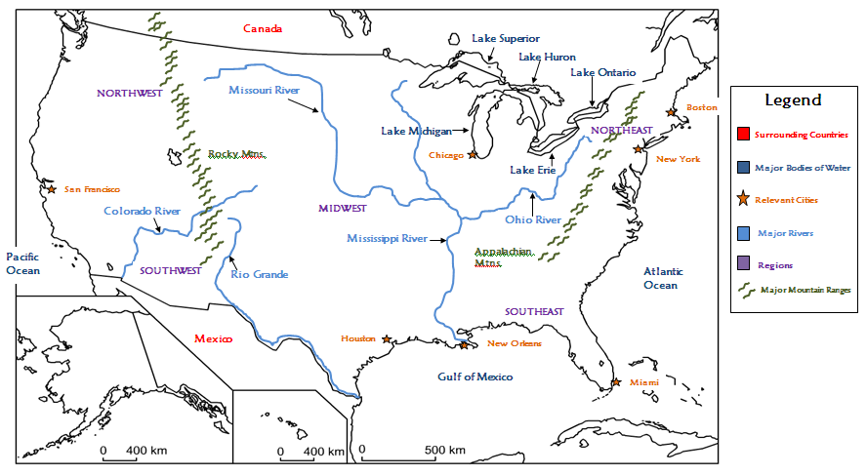

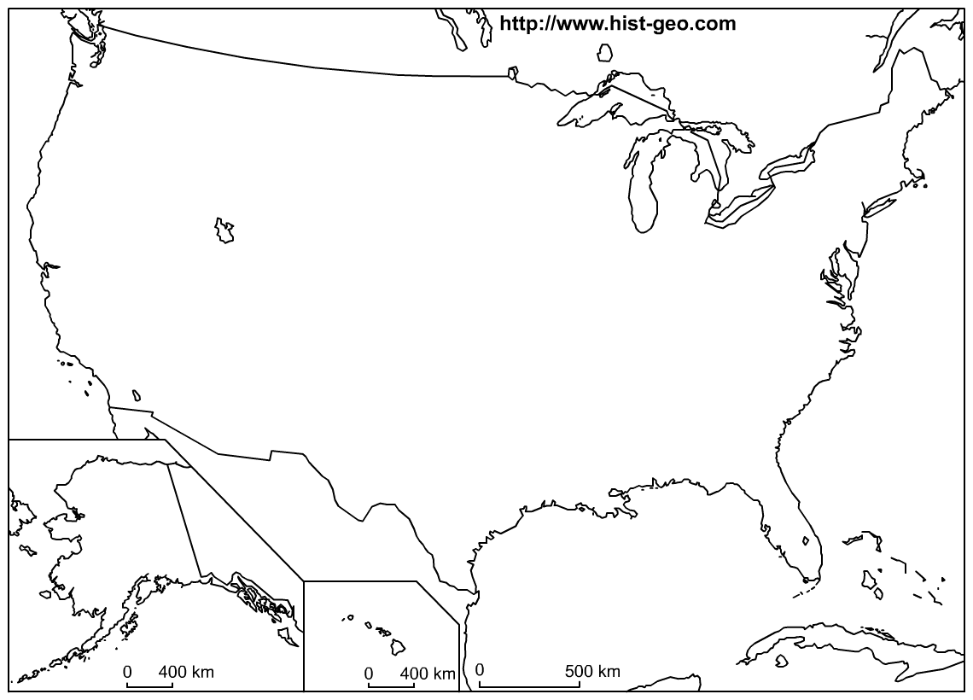
Legend

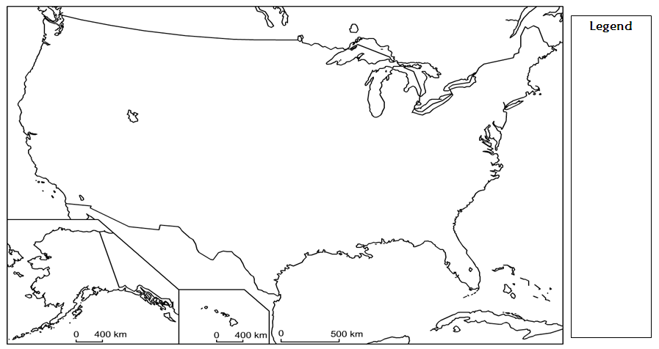

North Carolina Mapping from Memory Activity

Directions:
- Sketch the geographical features ex. rivers, mountains, etc. on the North Carolina map. Sketch the symbol of the geographical feature and its label in the legend.
- Label the map with the following:

Regions  Estimate boundaries & lightly color each region.  Tidewater  Coastal Plain  Piedmont  Mountains | Relevant Cities  Wilmington  Charlotte  Raleigh  Greensboro  Asheville | Major Bodies of Water  Pamlico Sound  Albemarle Sound  Atlantic Ocean
Surrounding States  Virginia  Georgia  Tennessee  South Carolina | Coastal Features  Outer Banks  Cape Fear  Cape Lookout  Cape Hatteras  Roanoke Island | Fall Line  Another geographic feature. Draw this line in red.
Rivers  Estimate the path of each river.  Cape Fear River  Roanoke River  Neuse River  Tar River | Mountain Range  Appalachian Mountains

