Common Core Lesson Plan

Topic: Unit One- Geography of NC

Resources (primary resource documents, artifacts, material needs, etc.)
- Interactive Notebook/class notebook
- 5 Themes of Geography Handout
- Brochures and other information about different locations in North Carolina
- Paper, colored pencils, scissors, and other classroom materials

Common Core Standards
- RH 1, 2, 5, 7
- WHST 4, 7, 8

Essential Standards
- 8.G.2: Understand the human and physical characteristics of regions in North Carolina and the United States.
- 8.G.1: Explain how location and place have presented opportunities and challenges for the movement of people, goods, and ideas in North Carolina and the United States.

Background Information
- Previous knowledge of how to read a map, 5 themes of geography and regions in the State of North Carolina.

Instructional Sequence (before, during, and after instruction)

DAY ONE and TWO: 5 Themes of Geography

Step 1:
Journal Question/Entrance Card: Based on your previous knowledge and information you see around the classroom, what are the five themes of Geography? Why are they important in our study of North Carolina/the United States?

Step 2:
Discussion of Journal Entry and entrance card. Briefly go through the five themes of geography and their importance. (Think, Pair, Share)

Step 3:
Hand out North Carolina brochures and other resources concerning the five themes of geography.

Step 4:
Using the information handed out and discussed at the beginning of the unit, create an accordion foldable (or booklet) about the five themes of Geography. (This should take the majority of the class period) Make sure to include the following information:
- Title Page: Your name, and the title of your foldable
- Location: Absolute vs. Relative Location. Describe both terms as they relate to NC. Include a drawing or diagram.

- Human/Environment Interaction: Define the term, and include examples from brochures/newspapers. Include a drawing or diagram.
- Movement: Define the term and give examples in NC. Include a drawing or diagram
- Region: Define the term and give examples in NC.

Step 5:
Glue the foldable into your interactive notebook on the right hand side.

Step 6:
Reflection Questions: To be written and answered on the left hand side
- What new information did you get from the brochures and newspapers?
- How do the Five Themes of Geography Affect our everyday life in North Carolina?
- What do you hope to learn more about throughout our discussion of North Carolina geography?

Step 7:
Homework (to be done throughout the week): Create a North Carolina Brochure. The brochure should include information from all three regions of the state.

DAY THREE: Geography of North Carolina

Step 1:
Journal/Entrance Card: Identify some of the characteristics of each region in North Carolina. The regions are: Tidewater, Coastal Plain, Piedmont, Mountains.

Step 2:
Discuss journal question in pairs and throughout the class.

Step 3:
Lead discussion on the regions of North Carolina and their major characteristics. Create and use a PowerPoint presentation with notes.

Step 4:
Glue the notes into interactive notebook.

Step 5:
Using the information presented in class identify the regions of NC on a blank map. Then, draw five major characteristics of each region.

Step 6:
Glue the map into your interactive notebook on the right side. On the left time, answer the following question in paragraph format: In which of the regions would you most like to live? Why? Make sure to include good supporting details.

Step 7:
Homework (to be done throughout the week): Create a North Carolina Brochure. The brochure should include information from all three regions of the state.

DAY FOUR and FIVE : Road Map of North Carolina

Step 1:
Journal/Entrance Card: What are some of the challenges in reading a road map? Why is this an important skill to have (in the age of GPS)?

Step 2:
Discuss in pairs, and in the group.

Step 3:
Hand out North Carolina Road Maps and Ipads (break class down into groups of three to four- each should have a road map and an Ipad). Hand out North Carolina Road Map Activity.

Step 4:
Use the North Carolina Road map to answer the first page of questions about North Carolina. When you complete the road map portion of the assignment, check in with your teacher. If you have completed the assignment well you will be given an Ipad for the second page of the assignment.

Step 5:
When the assignment is complete, make a T Chart in your interactive notebook. On this T chart, list the positives and negatives of using technology (like GPS) and the positives and negatives of using a traditional roadmap.

Step 6:
Write a brief paragraph explaining why it is important for students to learn how to read a road map, in addition to using technology.

Step 7:
Homework (to be done throughout the week): Create a North Carolina Brochure.

DAY SIX: Bringing it all together- How does geography influence the people of NC

Step 1:
Journal/Entrance Card: How does geography influence the people of North Carolina? (answer this question in groups)

Step 2:
Brief teacher led discussion on the best ways to outline/take notes on primary sources.

Step 3:
Classroom will be divided into stations. Each station will represent a major aspect of North Carolina Industry (Agriculture, Manufacturing, Tourism, Technology, Education and Health Services). Each of these stations will have information about each industry within North Carolina. Students will have ten minutes in each station to take notes and outline important information.

Step 4:
Pre- writing activity: Students will use the remainder of the class time to outline an essay answering the journal question (How does geography influence the people of North Carolina). Students should use all of the information given to them throughout class- including the foldable on the five themes of geography, notes on the regions of North Carolina, the roadmap activity, and the information gained about NC industry.

Step 5:
Have a classmate or a parent help you to revise your information for class tomorrow.

Day Seven: Assessment

Step 1:
The teacher will check to make sure that your pre-writing is complete. If it is not complete, the student will take time to complete it during class. If it is complete, the student may begin writing their essay.

Step 2:
Students will write an essay using their pre writing activity and any information given in class. This essay must completely answer the question “How does geography influence the people of NC?” Students will have the entire class period to answer the essay question.

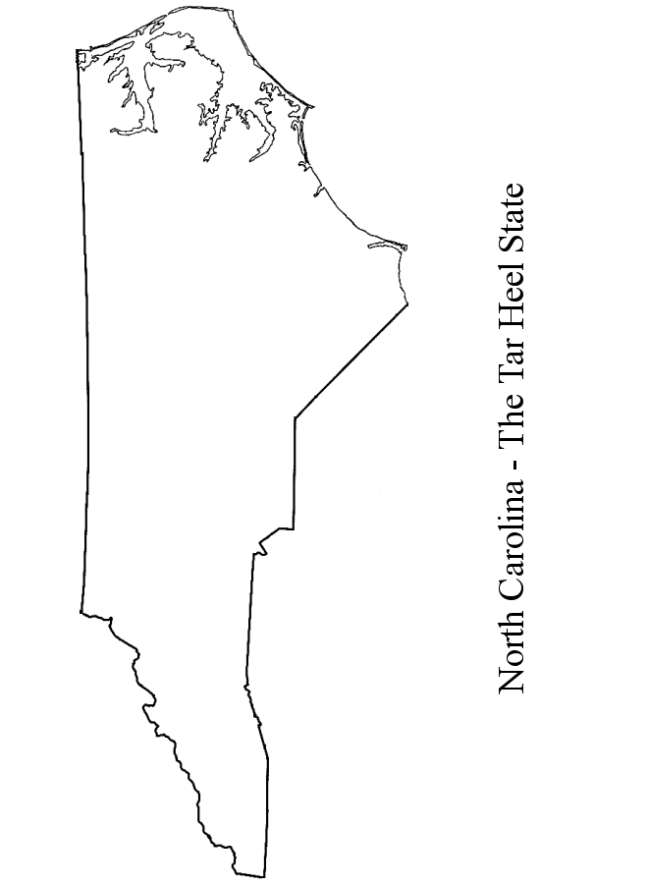

Map Key
Color | Feature
Blue | Mountains
Red | Piedmont
Dark Green | Coastal Plain
Light Green | Tidewater
Black | Fall Line
Star | Raleigh

Five Themes of Geography Foldable

Using the information handed out in class, and discussed at the beginning of the unit, create an accordion foldable (or booklet) about the five themes of geography.

Step One: Create your Foldable
Your foldable should include the following information:

Title Page: Your name, and the title of your foldable

Location: Absolute vs. Relative location. Describe both terms as they relate to NC. Include a drawing or diagram.

Human/Environment Interaction: define the term, and include examples from brochures/newspapers. Include a drawing or diagram.

Movement: Define the term and include examples from brochures/newspapers. Include a drawing or diagram.

Region: Define the term and give examples in NC
This foldable is to be completed during class. If you do not complete it during class, you may complete it during lunch, or for homework.

Step Two: Glue and Answer
When you are done with your foldable, please glue it on the right hand side of the next clear page in your interactive notebook.

Answer the following questions on the left hand side:
- What new information did you get from the brochures and newspapers?
- How do the five themes of geography affect our everyday life in NC?
- What do you hope to learn more about throughout our discussion of NC geography?

Geography of North Carolina: Guided Notes

- Basic Facts:
- Located in _______________________________ United States.
- Bounded
- on the ___________________________ by Virginia
- on the west by ______________________________.
- on the ____________________ by _______________ and South Carolina
- on the ___________________ by Atlantic Ocean
- its longest east-west point is about _______________________________________.
- its ______________________________north-south point is about _____________miles
- covers _________________________________ miles
- is about the size of __________________________________.
- is known as one of the ___________________________ states

- North Carolina has three distinct ________________________________________.
    - What is the break down of the word geography?
      - Word:___________________________________
      - Word Parts: ______________________________
      - Definition: _______________________________

- The Coastal Plain
  - located between _______________________ and the ________________________
  - covers nearly _______________ of state’s ____________________________
  - elevations range from _____________________ to _________________ ft. at the ______________________________.
  - The Coastal Plain is Divided into Two Sections
    - ______________________________________________
    - from the _____________________ to about __________________ miles inland
    - contains a series of ________________________ that border the ocean known as the _______________________________.

- Tidewater
  - _____________________________ (parts of the islands that _________ far out into ocean):
  - Cape ________________________, Cape _______________________ Cape __________________________.
  - _________________________________________ water off the shores causing _______________________ to __________________________________.
  - In 1800’s _____________________ were built to help warn ships _________________________ from dangerous waters.
  - Cape Hatteras and Cape Lookout national ___________________________ (stretch ___________________ miles along coast)

- Sounds
  - West of the barrier islands is an almost __________________ ____body of water that consists of ______________ major _______________________________:
  - _________________________________________
  - Albemarle (________________________________ is located between this sound and Norfolk, VA)
  - _____________________________ (Lake ___________________________________ located between Pamlico & Albemarle Sounds)
  - ___________________________________________
  - ___________________________________________

- Major Tidewater Towns
  - ___________________________________________
  - New Bern
  - ___________________________________________
  - Elizabeth City
  - Beaufort
  - ___________________________________________
  - Southport
  - ___________________________________________

- Inner Coastal Plain
  - stretches ____________________-100 miles from Tidewater to ________________________.
  - contains ____________________________—prime _________________________ region
  - Main crops - _________________________________, ____________________________, corn, wheat.
  - Beef & dairy cattle, hogs, & __________________________________- common livestock.
  - Sand hills
    - named because of ____________________—noted for its _________________ courses
  - Major Inner Coastal Plain Towns
    - _______________________________________________
    - Goldsboro
    - _______________________________________________
    - Southern Pines
    - Rocky Mount
    - ________________________________________________
    - ________________________________________________

- Piedmont Region
  - located between the fall line and the ___________________________________.
  - stretches approximately _________________________ miles
  - covers nearly ____________________ of state’s landmass
  - __________________________ from _____________________ ft. (moving ____________________________)

  - Center of the state’s _______________________________.
  - Raleigh
  - ______________________________________________
  - ______________________________________________
  - ______________________________________________
  - Durham
  - Center of state’s ________________________________________________________________________________________________________________________________________________
  - Before ______________________, NC was the country’s leading ________________________ producing state
(In Charlotte the _____________________________government once _________________________ coins)
  - ______________________________________ soil--variety of _______________________________.
  - Center of _____________________________________________________.
  - Center of _____________________________________________________.

- Mountain Region
  - located between ___________________________ and _________________________________
  - covers ___________________________________ square miles
  - elevations from _______________________________(east) to ________________________ ft.
  - __________________________________________--highest peak in _________________________ U.S.)
  - about ____________________________________ long and ____________________________ miles wide
  - ______________________________: The State’s Only Native American Reservation
  - _______________________________: The largest City of the region
  - State’s Largest National Parks: ____________________________________________

Geography of North Carolina: Road Map Activity

USE THE FRONT OF THE ROAD MAP TO IDENTIFY THE FOLLOWING:

Using the Legend (lower right hand side of map): Identify the following symbols.
1. The symbol for County Seat ___________________
2. The symbol for Points of Interest _____________________
3. One inch on the “Scale of Miles” equals approximately _____________ miles.
4. How many Interstate Highways run through North Carolina? ___________
5. Name these highways. ___________________________________________________________________

Using Coordinates (columns on the left hand side of the map): What are the coordinates of each location?
6. Brevard ______ 8. Seagrove ______
7. Zirconia ______ 9. Portsmouth ______

Following Directions: Where would you be if you followed these directions?
10. Leave Robbins. Travel 12 miles northwest on Highway 705. _________________________
11. Leave Bat Cave. Travel 3 miles southeast on Highway 64. _________________________
12. Leave Creedmoor. Travel 3 miles west to I-85.
Then, travel 20 miles northeast on I-85. _________________________
13. Leave Wilson. Travel 4 miles south on Highway 264A.
Then, travel 26 miles southeast on Highway 264. __________________________

Using Map Coordinates: Locate in each of the coordinates.
18. F-3 ( the LARGEST city) _________________________________
19. H-4 (lake) _________________________________
20. B-3 (forest) _________________________________
21. K-2 (historic site near Phelps Lake) _________________________________

Latitude/Longitude: What are the degrees of latitude or longitude for the following locations?
22. Topsail______________ north latitude 24. Chapel Hill ______________ west longitude
23. Mount Airy ______________ north latitude 25. Boone ______________ west longitude

Using Distance Table: (lower center of the map) How many miles are between each of these cities?
26. Raleigh to Morehead City _____________ miles 28. Asheboro to Asheville _____________ miles
27. New Bern to Cherokee _____________ miles 29. Murphy to Manteo _____________ miles

What other important information does the road map give you? (give at least five examples).

USE THE COMPUTERS OR IPADS TO ANSWER THE FOLLOWING QUESTIONS

Go to Google Maps and set North Carolina as your location. Using the North Carolina Map Answer the following questions:

- How is traffic flow from Raleigh, NC to Charlotte, NC? _______________________________________________

- List three of the photos given of important spots in North Carolina.
  - ____________________________________________________________________________

  - ____________________________________________________________________________

  - ____________________________________________________________________________

- What are the current weather conditions in Elizabeth City, NC? ________________________________________

Now set Raleigh, NC as your location. Answer the following questions:

1.What is the large park in northwestern Raleigh? _____________________________________________

2.Where are some of the best bicycle paths in Raleigh? _______________________________________

3.What do you see in the Raleigh Webcam? How is it different from the Durham webcam?

__________________________________________________________________________________________

4.Using the Wikipedia application (click on the BIG W in the middle of Raleigh), give a brief description of Raleigh including the population, a description of its nickname, and general location statistics.
__________________________________________________________________________________________________________________________________________________________________________________________________________________________________________________________________________________________________________________________________________________________________________________________________________________________________________________________________

Click on the Get Directions tab to the left of the screen. Answer the following questions:

- What are the driving directions from Daniels Middle School to North Carolina State University?
- ___________________________________________________________________________
- ___________________________________________________________________________
- ___________________________________________________________________________
- ___________________________________________________________________________
- ___________________________________________________________________________
- ___________________________________________________________________________

- How many suggested routes are there? __________________________________________________________

- How far is the drive? How long will it take? ______________________________________________________

- What are the directions from Daniels Middle School to one of your favorite spots in Raleigh (the mall, Baskin Robbins, the park)?
________________________________________________________________________________________________________________________________________________________________________________________________________________________________________________________________________________________________________________________________________________________________________

North Carolina Brochure Activity Rubric

For homework this week, you will create a North Carolina travel brochure. Your brochure should include information about all three regions of North Carolina while persuading visitors to come to each region. You may use a computer to create this brochure, or feel free to write out information (make sure I can read your handwriting). Be Creative!

Please turn this in with your brochure for your full grade! Make sure that your name is on this paper as well as on the back of your brochure.

_____/10: Your brochure is neat and colorful.
Comments:

____/ 50: Your brochure discusses all three regions of North Carolina. You have included at least one paragraph concerning each of these regions. The paragraph includes explanations of each region’s geography, climate, and important attractions!
- Coastal Plain (including the Tidewater Region)
- Piedmont Region
- Mountains
Comments:

_____/ 20: Your brochure uses correct spelling, grammar and punctuation.
Comments:

____/ 20: You followed instructions when completing the brochure.
Comments:

____ / 100 Total Grade

Additional Comments:

