Event | What Happened? | Good/Bad or  inevitable/avoidable  for America | Visual
The Cotton Gin | 1. Who created it?  2. Why was it created?  3. What does it do?  4. What effect did it have on slavery? |  | 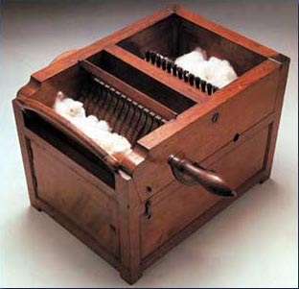
The War of 1812 | 1.What events led up to the war?  2. Which country attacked America?  3. Who wins most of the war?  4.What city was burned to the ground?  5. Which cities were targeted for destruction?  6. Why was the “Star Spangled Banner” written? |  | 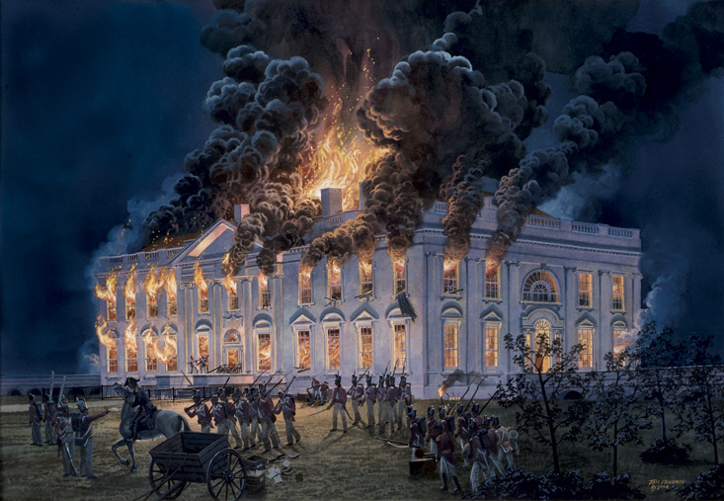
Manifest Destiny | 1.Explain it:  2. What was good and bad about the era? |  | 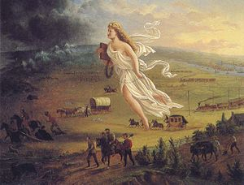
Monroe Doctrine | 1.What does it decree?  2. Was POTUS Monroe right for issuing it and why? |  | 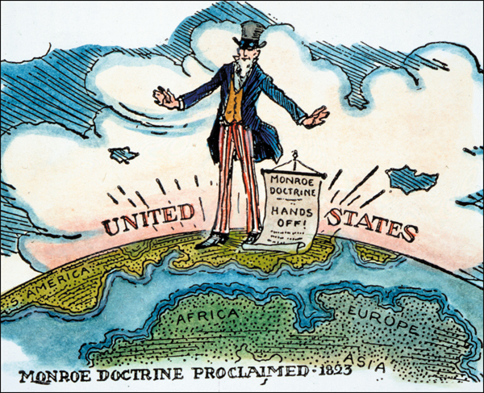
Sectionalism | 1.What is it?  2. What event and regions were using sectionalism to drive the country apart? |  | 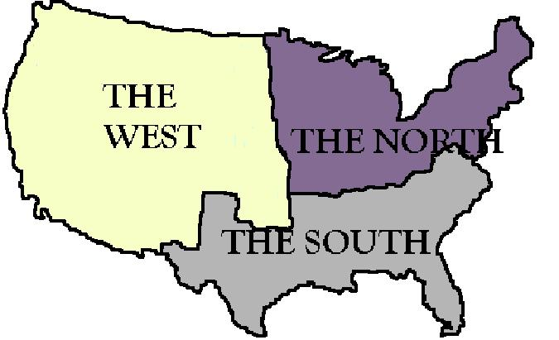
Nationalism | 1.What is it?  2.What is good and bad a bout it? |  | 

