What to Include:
- Explain the physical characteristics of (1 paragraph minimum):
- Tidewater Region
- Piedmont Region
- Coastal Plain Region
- Mountain Region
- Picture of each region
- Key Information of each region:
- Major cities
- Major industries
- Major attractions/tourist destinations
- State flag in color
- Outline of state listing the items in #3
- Your name and section

Miscellaneous:
- You may print or hand write all information
- You may use the internet or draw your photos
- You may use front and back and/or fold the brochure how you like
- This is your first project, make sure you do you best and submit a finish product that you are proud of
Examples:
 or your own design (please not a poster)
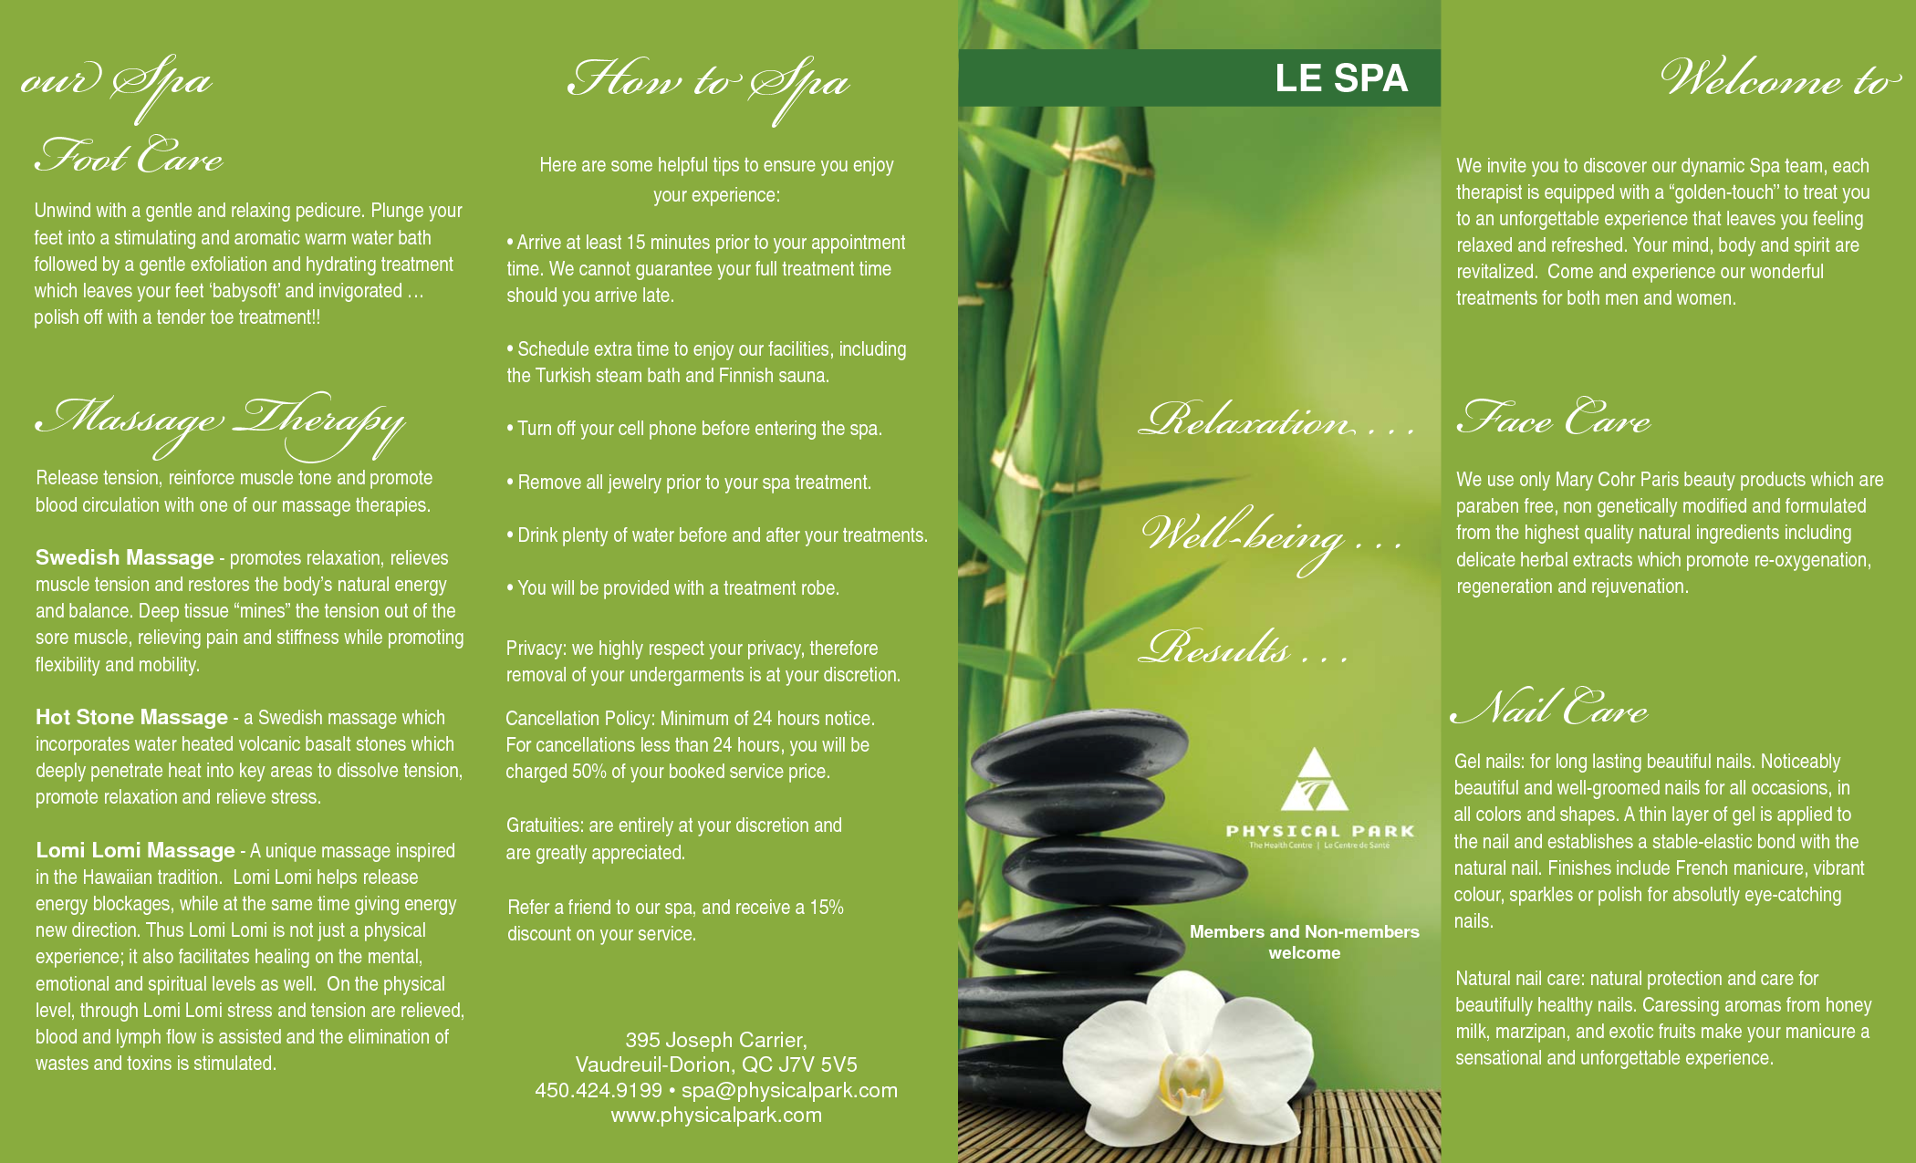 or your own design (please not a poster)

