Constructed Response Samples
The following samples of constructed response questions were not necessarily generated by DPI. They do, however, represent the types of questions DPI may use on the Social Studies Common Exams for the 2012 – 2013 school year. In open-ended questions such as these students are asked to demonstrate what they know by citing specific examples, either from memory or from provided materials, of their choosing. This means that students are expected to support their conclusions. Students are then assessed based on the content of their responses and their answer’s alignment to the prompt, not on format. This means that a bulleted list is scored no differently than a well-structured, multi-paragraph response. In other words, it’s the content that counts.

Document/Resource-Based Questions

DPI Sample:
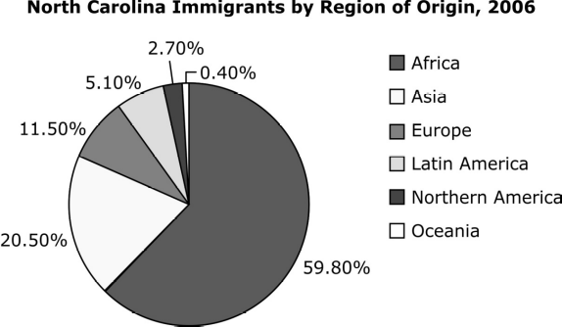

The pie chart shows the immigrant distribution of North Carolina’s population in 2006. Explain how three immigrant groups from the chart contributed to the development of North Carolina.

NY Regent Samples:

. . . Be it enacted by the Senate and House of Representatives of the United States of America in Congress assembled, That from and after the first day of January, one thousand eight hundred and eight [1808], it shall not be lawful to import or bring into the United States or the territories thereof from any foreign kingdom, place, or country, any negro, mulatto, or person of colour, with intent to hold, sell, or dispose of such negro, mulatto, or person of colour, as a slave, or to be held to service or labour. . . .

According to this law, what restriction did the United States Congress place on slavery in 1808?

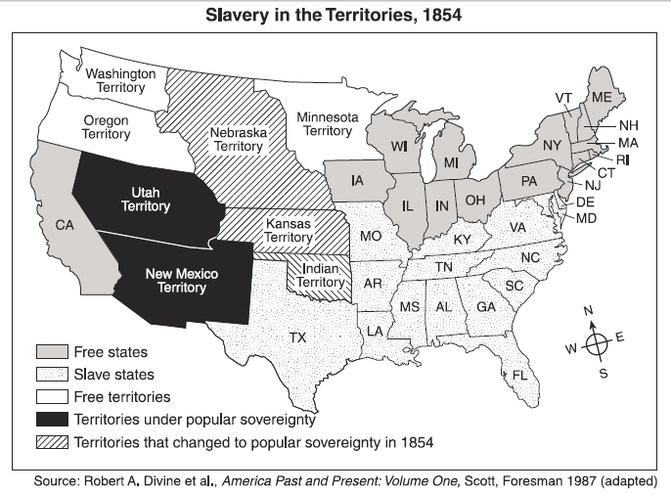

Based on this map, state one way the United States government dealt with the issue of slavery in the western territories.
Questions w/o Resources Provided
DPI Samples
• Choose a key historical figure that transformed a society. Construct a cause and effect graphic that shows how this historical figure helped to transform his or her corresponding society economically, culturally, and politically.
• Explain three ways that the internet has impacted global markets.
• Create a cause and effect chain of events explaining the political, social, and economic outcomes of the Civil Rights Movement in North Carolina.

Wake County Teacher Samples
6th Grade
- How can primary sources influence our understanding of historical events in ways that other sources can’t?
- What common geographic factors contributed to the Agricultural Revolution in multiple locations?
- How have various societies been transformed by specific historical figures?
- What factors have influenced the movement of people, goods, and ideas?
- How have civilizations adapted to their environments?
- How has conflict over the availability of resources impacted economic decisions of various civilizations?
- How has democracy evolved over time?
- How has the concept of divine right shaped various civilizations?
- How have variations in the definition of citizenship affected political developments in various civilizations?
- How have religious beliefs and traditions transformed societies over time?
- Why do empires always seem to fail?
7th Grade
- How can primary sources influence our understanding of historical events in ways that other sources can’t?
- In what ways are the effects of imperialism still felt today?
- How has international cooperation benefited global markets?
- How have technological innovations affected the movement of goods, people, and ideas?
- How has disease impacted the political and economic stability of modern societies?
- How has the scarcity of resources affected the modern political landscape?
- How has the modification and use of the environment affected modern societies?
- How do capitalism, socialism, and communism differ?
- How have philosophic changes revolutionized political and/or religious systems?
- How has competition among modern superpowers affected the political and economic systems of the third world?
- How has the legacy of the global slave trade shaped modern societies?
8th Grade
- How can primary sources influence our understanding of historical events in ways that other sources can’t?
- What historical events shaped the political ideals of the Founding Fathers?
- How has the conflict between federalist and anti-federalist groups affected political developments in the United States?
- How did the philosophy of Manifest Destiny impact native peoples and other colonial powers?
- How have confrontation and compromise shaped the political evolution of the State of North Carolina?
- Why did the Northern States win the Civil War?
- How have advances in transportation affected the development of the United States since its inception?
- How have dynamic leaders influenced the outcomes of cultural conflicts in North Carolina?
- How have the cultural traditions of the Eastern Hemisphere affected societal norms in the United States/North Carolina?
- How has geography shaped economic development in various regions across the United States?
- How have political conflicts affected economic growth?

Grade 6 - Quarter 1
Standards: WHST.8.1, RHST.8.7, 6.G.1.1

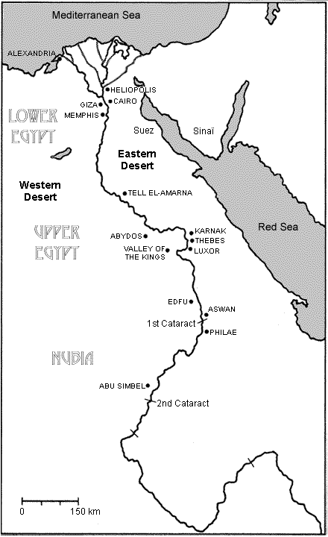
http://www.civilization.ca/cmc/exhibitions/civil/egypt/egcgeo1e.shtml

Question: Using this map of ancient Egypt how did the Nile River influence the development of that civilization? Provide two examples from the map to support your answer. (3 pts.)

Grade 6 – Quarter 1
Standards: WHST.8.2, RHST.8.2, 6.C.1.1

INCA CREATION MYTH
In the beginning, Pachacamac the sun rose slowly from Lake Titicaca. Pachacamac was so bright that nothing else could be seen in the sky but him. But the night sky was empty; so he made the stars, the planets and the moon. The beautiful moon, Pachamama, became his wife and together they ruled the heavens and the earth. Pachacamac fashioned the first humans from the stone of an enormous mountain of rock. The first humans were pitiful creatures; they knew nothing of the world nor how to survive in it. The sun and the moon bore a son and a daughter. Out of pity they sent their children to the earth to help them. The son of Pachacamac taught men how to plow and plant the fields, and how to build houses. The daughter of the moon approached the women and taught them the art of weaving, and how to prepare food. “Teach the humans to be kind and fair. I will provide light and warmth, every day without fail; but make sure they never forget their creators.”
http://www.mythicjourneys.org/bigmyth/myths/english/2_inca_full.htm

Question: Describe two values (citing examples from the text) that we can learn about the Incas from this creation myth. (2pts.)

Grade 6 - Quarter 2
Standards: WHST.8.1, RHST.8.6, 6.C.1.1

Pericles Funeral Oration
I will speak first of our ancestors (family members who came before us), for it is right that now, when we are lamenting (sadly remembering) the dead, a tribute should be paid to their memory. There has never been a time when they did not inhabit (live in) this land, which by their valor (bravery) they handed down from generation to generation, and we have received from them a free state. And we assembled here today have carried the work of improvement further, and have richly endowed (provided) our city with all things, so that she is sufficient (well supplied) for herself both in peace and war.
Before I praise the dead, I should like to point out by what principles of action we rose to power, and under what institutions and through what manner of life our empire became great.

Question:
“Pericles is discussing the dead in order to inspire the living.”
Is this statement true or false? Cite two examples from the text to support your answer. (3 pts.)

Grade 6 Quarter 3
Standards: WHST.8.2, RHST.8.7, 6.E.1.2

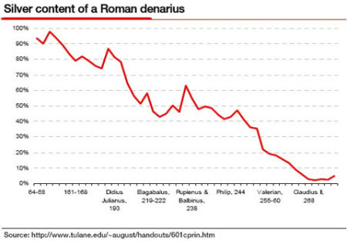

Question: Use the graph above to describe the Roman economy. What was one factor that led to this trend? (2 pts.)

Grade 6 - Quarter 3
Standards: WHST.8.2, RHST.8.7, 6.H.1.3

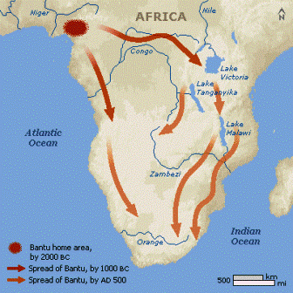
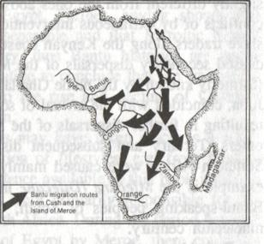

Question: These maps show two different theories of the migrations of the Bantu people across Africa. Describe each theory of Bantu migration. Explain one way this migration might have influenced the other peoples in Sub-Saharan Africa. (3pts.)

Grade 6 – Quarter 4

“The city has many squares where markets are held and trading is carried on. There is one square…where there are daily more than 60,000 souls, buying and selling, and where are found all the kinds of merchandise produced in these countries, including food products, jewels of gold and silver, lead, brass, copper, zinc, bones, shells, and feathers.”
Hernán Cortés, 1519

Cite one example that indicates the Inca had an advanced economy.
Explain two reasons Cortes may have been interested in the resources of the Inca.
(3 points)

Grade 6 – Quarter 4

Source A

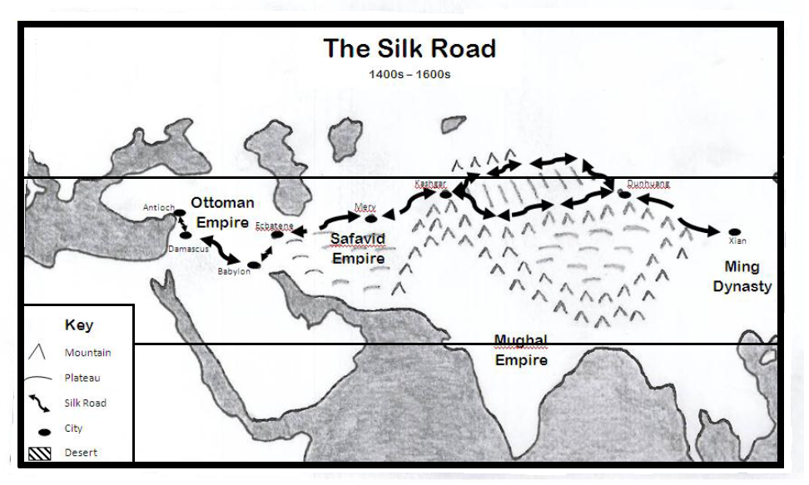

Source B
Buddhism Introduced to China from the Silk Road
It is not certain when Buddhism reached China, but with the Silk Road opened in the second century BC, missionaries and pilgrims began to travel between China, Central Asia and India. The record described that Chang Ch'ien, on his return from Ta-hsia (Ferghana) in the 2nd century BC, heard of a country named Tien-chu (India) and their Buddhist teaching. This is probably the first time a Chinese heard about Buddhism. A century later, a Buddhist community is recorded at the court of a Han prince…... This was the first time that China had Buddhist monks and their ways of worship. A few years later, a Buddhist community was established in Loyang, the capital, itself. From then on, the Buddhist community grew continuously.

Describe one hardship faced by a European merchant traveling on the Silk Road. Given these hardships, explain one reason European merchants continued to trade along the Silk Road. What role did the Silk Road play in the spread of Buddhism from India to China? (3 points)

Grade 6 – DPI

Select an event or issue from the past that is similar to an event or issue that is happening today. Give one example of how that event or issue is similar to what is happening today, and give one example of how that event differs from what is happening today.

Grade 6 – Quarter 4

Blessings result when you respond to Heaven by creating order; misfortune results when you respond to it with disorder.
When you concentrate on agriculture and industry and are frugal in spending, Heaven cannot make your country poor. When you store provisions and act quickly in emergencies, Heaven cannot inflict illness on your people. When you are single-minded in your cultivation of the Way, Heaven cannot send disasters. Thus, even if they come, droughts and floods will not bring starvation, extremes of temperature will not bring illness, uncanny phenomena will not prove unlucky.
On the other hand, if you ignore agriculture and industry and spend in an extravagant manner, then Heaven cannot make your country rich. If you are negligent concerning provisions and slow to respond to crises, Heaven cannot keep your country whole. If you renounce the Way and act recklessly, Heaven cannot make you lucky. In such a case, starvation will result even without flood or drought; illness will occur even without severe weather; misfortunes will occur without any uncanny phenomena…
SOURCE: Xunzi, a Confucianist, from Xunxi [213 BCE]

Describe two effects Xunzi attributes to following “the Way” and two effects he attributes to renouncing “the Way”. (4 points)

Grade 7 - Quarter 2
Standards: WHST.8.2, RHST.8.6, 7.H.1.3

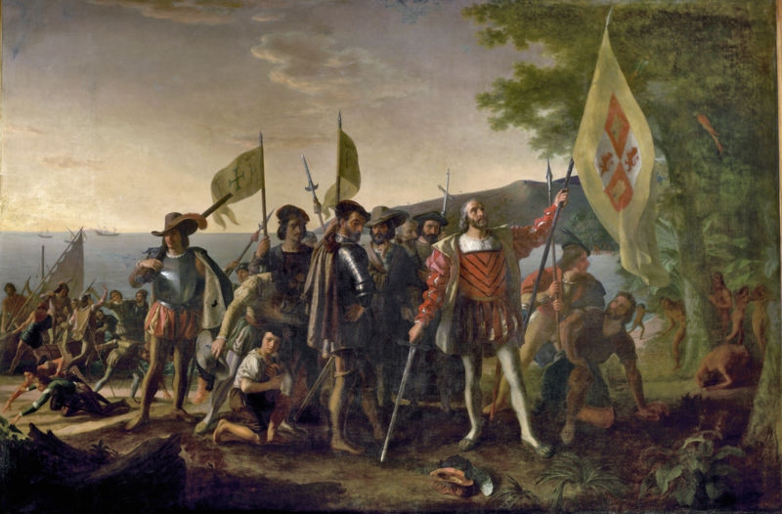

Question: Artists often place their own biases into their work without knowing it. Describe how this painting of Columbus landing in the New World might show bias. Provide at least two examples. (2pts.)

Grade 7 - Quarter 2
Standards: WHST.8.1, RHST.8.1, 7.C.1.2

All power comes from God, I admit; but so does all sickness: does that mean that we are forbidden to call in the doctor? A brigand [bandit] surprises me at the edge of a wood: must I not merely surrender my purse on compulsion, but, even if I could withhold it, am I in conscience bound to give it up? For certainly the pistol he holds is also a power.
- Jean-Jacques Rousseau, The Social Contract

Question: Does Rousseau believe in the concept of fate (that all things are determined to happen)? Cite evidence from the passage to support your answer. (2pts.)

Grade 7 - Quarter 3
Standards: WHST.8.2, RHST.8.7, 7.C&G.1.2

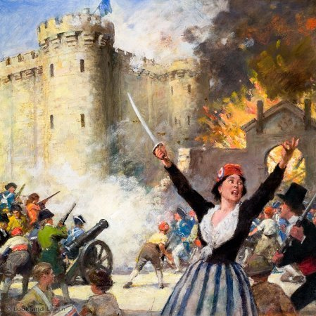

Question: What are three ways this iconic image of the storming of the Bastille illustrates the methods, goals, and values of the Third Estate in the French Revolution? (3pts.)

Grade 7 – Quarter 3

Requirements and Responsibilities of the Common French Citizen
 | Before the French Revolution | After the French Revolution
Requirements
Gender | Male | Male
Status | Nobility/clergy had more power than commoners | Status based on birth was outlawed
Wealth | Gave influence but no real power without status | Gave influence and power
Responsibilities
Taxes | Commoners pay all taxes/fees | Everyone pays the same
Duties | Absolute loyalty to king, work on public services (i.e. roads), don’t hunt on king’s hunting grounds (even if it’s your land), must be Catholic | Loyalty to the nation, military service

Describe two ways that the requirements and responsibilities of citizenship improved after the French Revolution and two ways it did not improve. (4 pts.)

Grade 7 - Quarter 3
Standards; WHST.8.2, RHST.8.7, 7.H.1.1

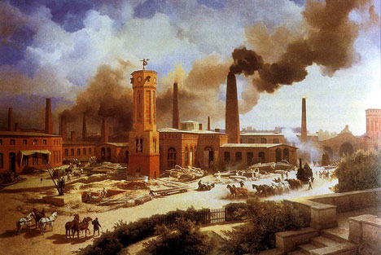
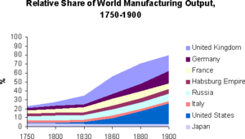

Question: Based on the images above, what were two of the changes brought about by the Industrial Revolution? (2pts.)

Grade 7 - Quarter 3
Standards: WHST.8.2, RHST.8.1, 7.E.1.1

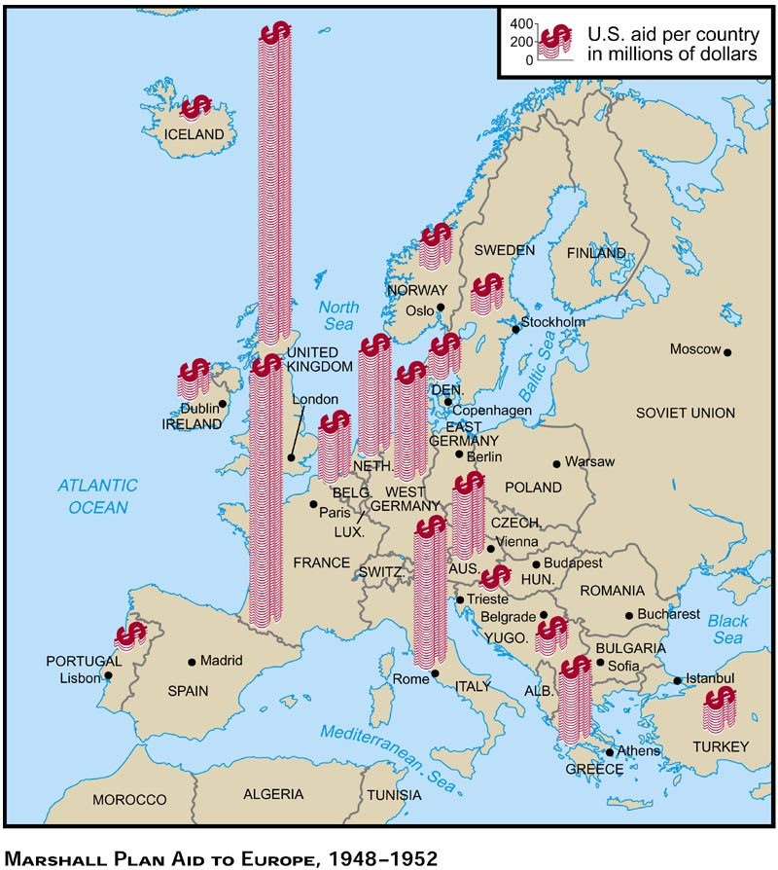
The Marshall Plan (EXCERPT)

The truth of the matter is that Europe's requirements for the next 3 or 4 years of foreign food and other essential products -- principally from America -- are so much greater than her present ability to pay that she must have substantial additional help, or face economic, social, and political deterioration of a very grave character. The remedy lies in breaking the vicious circle and restoring the confidence of the European people in the economic future of their own countries and of Europe as a whole. The manufacturer and the farmer throughout wide areas must be able and willing to exchange their products for currencies the continuing value of which is not open to question.

Question: What was the goal of the Marshall Plan? Cite two pieces of evidence from the sources provided. (3pts.)

Grade 7 - Quarter 3
Standards: WHST.8.2, RHST.8.7, 7.C&G.1.1

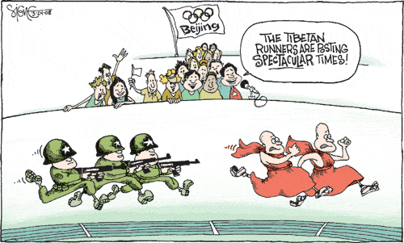
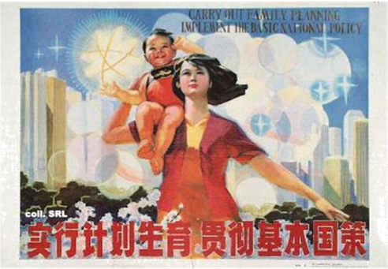

Question: How does each image illustrate the bias of its creator? (2pts.)

Grade 7 - Quarter 4
Standards: 7.E.1.1, 7.E.1.2
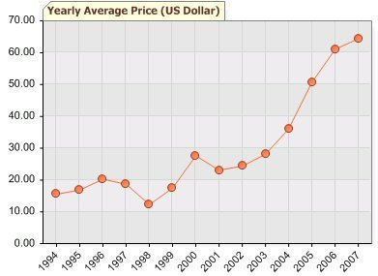
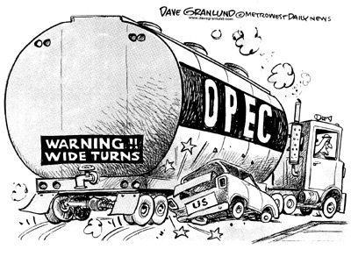

http://grzspace.blogspot.com/2012/05/opec-founding-weapon-question.html
http://thaicrisis.wordpress.com/tag/oil-energy/

Each of these images depicts the relationship between the United States and OPEC. What conclusion can be drawn about United States spending on OPEC oil and what is the cartoonist’s opinion about this relationship? (2 pts.)

Grade 7 – DPI

Economic Systems
• traditional
• command
• market
• mixed

Summarize one major feature that distinguishes each economic system.

Grade 8 - Quarter 1
Standards: WHST.8.2, RHST.8.7, 8.H.1.2

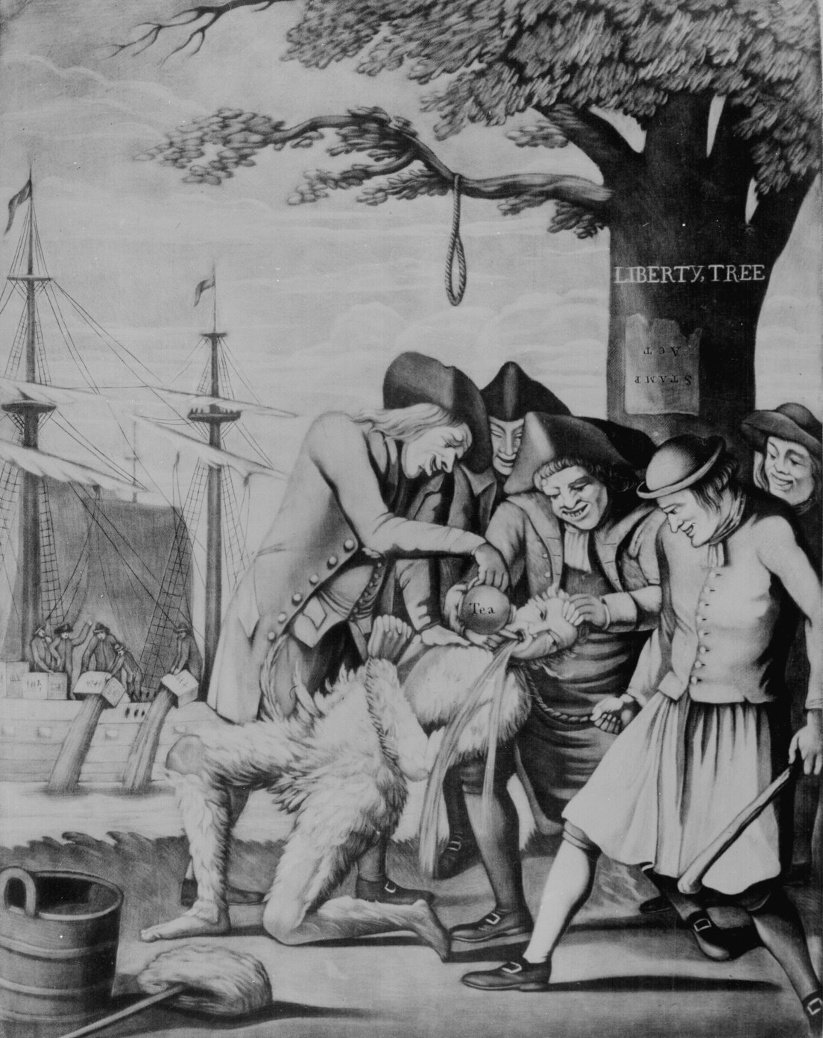

Question: Identify two ways in which the artist uses this print to express Loyalist views of the revolutionary movement. (2pts.)

Grade 8 - Quarter 1
Standards: WHST.8.2, RHST.8.7, 8.C.1.1

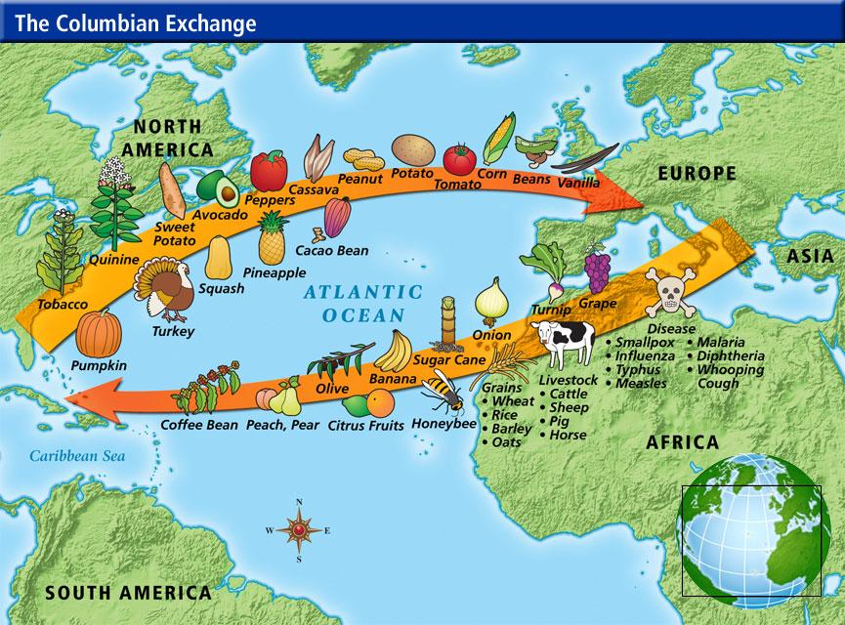

Question: Describe three ways the Columbian Exchange had a lasting impact on the world’s culture and/or economy. (3pts.)

Grade 8 - Quarter 1
Standards: WHST.8.1, RHST.8.2, 8.C&G.1.2

Preamble
We, the People of the United States, in Order to form a more perfect Union, establish Justice, insure domestic Tranquility, provide for the common defence, promote the general Welfare, and secure the Blessings of Liberty to ourselves and our Posterity, do ordain and establish this Constitution of the United States of America.

Article I, Section 2
...their respective Numbers, which shall be determined by adding to the whole Number of free Persons, including those bound to Service for a Term of Years, and excluding Indians not taxed, three fifths of all other Persons.

Amendment 15
The right of citizens of the United States to vote shall not be denied or abridged by the United States or by any State on account of race, color, or previous condition of servitude

Amendment 19
The right of citizens of the United States to vote shall not be denied or abridged by the United States or by any State on account of sex.

Question: How did the Founding Fathers define equal citizenship? What are two ways the definition of equal citizenship changed over time? (3pts.)

Grade 8 – Quarter 1
Standards: 8.C&G.1.1

Resolves Adopted in Charlotte Town, Mecklenburg County, North Carolina, May 31, 1775
This Day the Committee met, and passed the following resolves:
Whereas by an Address presented to his Majesty by both Houses of Parliament in February last, the American Colonies are declared to be in a State of actual Rebelion, we conceive that all Laws and Commissions confirmed by, or derived from the Authority of the King or Parliament, are annulled and vacated, and the former civil Constitution of these Colonies for the present wholly suspended...we deem it proper and necessary to pass the following Resolves…
[Resolve] 20: That this committee do appoint Colonel Thomas Polk, and Doctor Joseph Kennedy, to purchase 300 lb. of Powder, 600 lb. of Lead, and 1000 Flints, and deposit the same in some safe Place, hereafter to be appointed by the committee.

Who is the committee addressing with these resolves and what are they declaring? Why is the date of the Mecklenburg Resolves significant? What does Resolve #20 indicate that the authors were anticipating as a response to their declaration? (4 points)

Grade 8 – Quarter 2
Standards: 8.C&G.1.4

And is it supposed that the wandering savage has a stronger attachment to his home than the settled, civilized Christian? Is it more afflicting to him to leave the graves of his fathers than it is to our brothers and children? Rightly considered, the policy of the General Government toward the red man is not only liberal, but generous. He is unwilling to submit to the laws of the States and mingle with their population. To save him from this alternative, or perhaps utter annihilation, the General Government kindly offers him a new home, and proposes to pay the whole expense of his removal and settlement.
Andrew Jackson’s Message to Congress on Indian Removal (1830)

Provide two ways Andrew Jackson justified the forced removal of Native Americans from their ancestral lands? How does Jackson propose to compensate those moved by this law? (3points)

Grade 8 - Quarter 2
Standards:

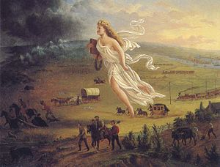
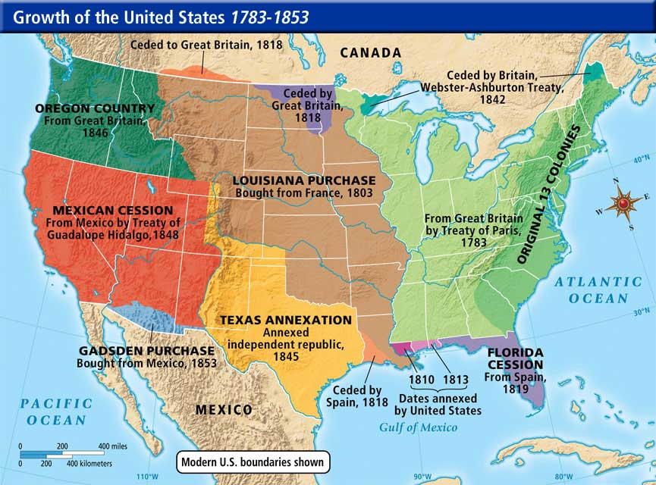

http://onlinemaps.blogspot.com/2012/11/united-states-western-expansion.html

Question: What are two ways these sources illustrate the idea of Manifest Destiny (the belief that the United States should control the land from one ocean to the other). (2pts.)
Standards: WHST.8.2, RHST.8.7, 8.H.3.1

Grade 8 - Quarter 3
Standards: WHST.8.1, RHST.8.6, 8.H.1.3

“The Flapper awoke from her [submission]…bobbed her hair, put on her choicest pair of earrings and a great deal of audacity and rouge and went into the battle. She flirted because it was fun to flirt and wore a one-piece bathing suit because she had a good figure … she was conscious that the things she did were the things she had always wanted to do. Mothers disapproved of their sons taking the Flapper to dances, to teas, to swim and most of all to heart."

Zelda Fitzgerald, “Eulogy on the Flapper”, Metropolitan Magazine (1922)

Question: Does the author of this writing have a positive or negative view of the flapper? Provide at least two examples from the quote to support your answer. (3pts.)

Grade 8 - Quarter 3
Standards: WHST.8.2, RHST.8.7, 8.H.1.5

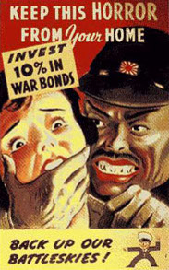
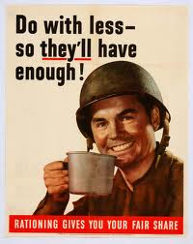

Question: These images are a sampling of posters from the United States during World War 2. Describe one purpose of propaganda and explain 2 methods from these images to achieve that purpose. (3pts.)

Grade 8 – Quarter 4

Excerpt A:
When Four students sat down at a lunch counter in Greensboro, N.C. [1960] they helped re-ignite the Civil Rights Movement.
The civil rights protests didn't end with a cup of coffee at Woolworth's. In 1963, another series of demonstrations in Greensboro—led by an A&T student named Jesse Jackson—targeted movie theaters and cafeterias, as well as discriminatory hiring practices. That same year, police in Birmingham, Alabama, responded violently to marches and sit-ins led by King. In both Greensboro and Birmingham, the jails overflowed with black students.
On June 11, 1963, President John F. Kennedy, in a live television address from the Oval Office, called for legislation that would give "all Americans the right to be served in facilities which are open to the public—hotels, restaurants, theaters, retail stores, and similar establishments."

Excerpt B:
"The civil rights movement would have moved much slower, would have accomplished far fewer victories if you had not had those student sit-ins and the entry into the movement of all this young energy," says Aldon Morris, author of The Origins of the Civil Rights Movement.

Identify two aspects of everyday life that were impacted by the sit-in of the Greensboro Four. Based on these events, what role do young people play in societal change? (3points)

Grade 8 – DPI

Identify three different immigrant populations that have settled in North Carolina from the pre-colonial era to the present day. Give one example of how each population contributed to the cultural development of North Carolina.

